How to Upload a Subaward Budget in Kuali Research
- Select and download the correct Subaward Budget Form and send it to your subrecipient to complete and return.
https://www.umaryland.edu/kualicoeus/user-resources-and-help/attachments/subaward-budgets/
- Ensure that the completed subaward budget has been fully completed:
- DUNS number of the subrecipient organization is required.
- Project period dates must match those of the proposal. An empty project year is not allowed.
- Person months must be entered for all personnel in all years. For inactive budget periods, provide a single entry including the following:
Subaward PI First and Last names
Project Role
Calendar Months = .01 (smallest amount effort allowed in the field)
Requested Salary = $0
Fringe Benefits = $0
- The Subaward Budget Justification must include an explanation of the inactive budget periods
- Subaward Budget Justification attachment must be a PDF document with a unique file name (not a file name used elsewhere in your proposal)

- Enter the detailed budget for the proposal and autocalculate periods. All years of the UMB budget must be generated before you upload a subaward budget form.

- Navigate to Subawards

- Click +Add Subaward. A pop-up window will open. In the Add Subaward window:

Organization Id field: Search for the Organization. The Organization lookup will open in a pop-up window. Search for an Organization ID that you know or use a wildcard search in the Organization Name field (EXAMPLE: *duke*). Select the Organization from the results.

NOTE: If the needed Organization is not listed, please complete the Address Request form and request to add this new subrecipient to Kuali Research. http://www.umaryland.edu/kualicoeus/user-access-and-requests/addressrequest/

File Name field: Browse for and upload the completed Subaward Budget form. Click the blue Add Subaward button
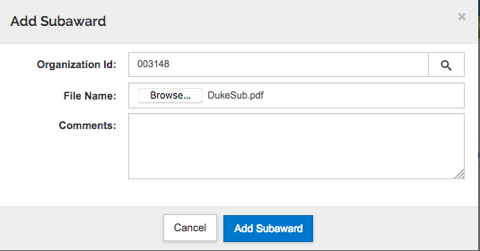

- The subaward now appears on the Subaward screen. Add other subrecipients and subaward budgets.
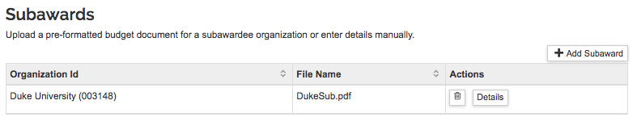
- Open the Summary to review how the costs are applied to the budget.
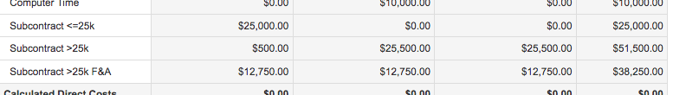
- If you are creating a modular budget, sync to the modular budget now that your budget is complete and all subawards have been uploaded.
- Return to the proposal
Use the Return to Proposal button at the top of the left navigation menu.

- Navigate to Basics > Organization and Location > Other Organizations tab. Check that the subrecipient(s) are included here. For S2S proposals, make sure that the Congressional District appears. If it does not appear, email SPA (jsimons@umaryland.edu and chunter1@umaryland.edu) to request that the Kuali Research record be updated.

- For S2S Proposals: Navigate to Basics > Opportunity Search > Forms tab.
- If you are submitting a Detailed budget, in the Include column, check the box to Include the RR_Budget and the RR_SubawardBudget.
- If you are submitting a Modular budget, in the Include column, check the box to Include the PHS398_ModularBudget.

